Cacti Plug-in
V100R002C30
 | User Guide
 | Issue | 01
 | Date | 2017-09-29


Preface
Purpose
This document describes how to install and uninstall the Cacti plug-in, how to view Huawei server information and performance curves, and how to monitor Huawei server status.
Intended Audience
This document is intended for:
- Installation and commissioning engineers
- Technical support engineers
Symbol Conventions
The symbols that may be found in this document are defined as follows.
Symbol | Description
 | Indicates an imminently hazardous situation which, if not avoided, will result in death or serious injury.
 | Indicates a potentially hazardous situation which, if not avoided, could result in death or serious injury.
 | Indicates a potentially hazardous situation which, if not avoided, may result in minor or moderate injury.
 | Indicates a potentially hazardous situation which, if not avoided, could result in equipment damage, data loss, performance deterioration, or unanticipated results.  NOTICE is used to address practices not related to personal injury.
Calls attention to important information, best practices and tips.
NOTE is used to address information not related to personal injury, equipment damage, and environment deterioration.

Change History
Changes between document issues are cumulative. The latest document issue contains all the changes made in earlier issues.
Issue 01 (2017-08-29)
This issue is the first official release.
Contents
Preface ii
1 Overview 1
2 Installing and Uninstalling the Cacti Plug-in 4
2.1 Installing the Cacti Plug-in 4
2.2 Uninstalling the Cacti Plug-in 6
3 Adding Servers 8
3.1 Manually Adding a Server 8
3.2 Importing Servers in Batches 10
3.3 Adding Servers by Automatic Scanning 13
4 Querying Server Information 17
4.1 Viewing Basic Server Information 17
4.2 Viewing Server Performance Curves 19

Overview
After the Cacti plug-in is installed, you can add Huawei rack servers, high-density servers, and blade servers, query Huawei server information, and create performance graphs.
- Table 1-1 lists the servers supported by the Cacti plug-in.
- Table 1-2 provides the information about the rack and high-density servers that can be queried by using the Cacti plug-in.
- Table 1-3 provides the information about the blade servers that can be queried by using the Cacti plug-in.
                - Supported servers
Type | Server
Rack server | RH2288H V2
Rack server | RH1288 V3
Rack server | RH2288 V3
Rack server | RH2288H V3
Rack server | 5288 V3
Rack server | RH5885 V3
Rack server | RH5885H V3
Rack server | RH8100 V3
Rack server | 1288H V5
Rack server | 2288H V5
Rack server | 2488 V5
High-density server | XH310 V3
High-density server | XH321 V3
High-density server | XH620 V3
High-density server | XH622 V3
High-density server | XH628 V3
High-density server | XH321 V5
Blade server | E9000

                - Rack and high-density server information that can be queried
Module | Function
iBMC | The iBMC version, CPLD version, Uboot version, IP address, and host name information can be obtained.
Mainboard | The mainboard model, ID, manufacturer, external name, and serial number information can be obtained.
BIOS | The BIOS version can be obtained.
DIMM | The DIMM quantity, slot, position, type, capacity, serial number, manufacturer, and bit width information can be obtained.
Power | The PSU quantity, position, manufacturer, and model, current power, peak power, average power, accumulated power consumption, whether the power capping function is enabled, and current power capping value can be obtained.
CPU | The CPU quantity, position, model, manufacturer, frequency, core quantity, and thread quantity can be obtained.
Hard disk | The hard disk quantity, capacity, manufacturer, type, interface type, maximum rate, negotiated rate, serial number, and physical slot information can be obtained.
RAID controller card | The RAID controller card quantity, model, and firmware version can be obtained.
Fan | The fan quantity, position, and rotation speed can be obtained.
Performance graph creation | The performance graphs of the CPU usage, total power consumption, current system power, and BMC air inlet temperature can be created.

                - Blade server information that can be queried
Module | Function
HMM | The HMM version, PCB version, CPLD version, Uboot version, IP address, and BOM version information can be obtained.
Manufacturing information | The chassis name, position, number, and manufacturing type can be obtained.
Power | The PSU quantity, current power, whether the power capping function is enabled, and current power capping value can be obtained.
Fan | The fan quantity and rotation speed can be obtained.
Blade | The blade slot number, BMC IP address, and GUID information can be obtained.
Blade DIMM | The blade DIMM quantity, position, capacity, and manufacturer information can be obtained.
Blade CPU | The blade CPU quantity, position, model, manufacturer, frequency, core quantity, and thread quantity can be obtained.
Blade hard disk | The hard disk quantity, capacity, manufacturer, type, interface type, serial number, and position information can be obtained.
Blade mezzanine card | The mezzanine card quantity, name, model, position, and MAC address information can be obtained.
RAID controller card | The RAID controller card quantity, model, and firmware version can be obtained.
Performance graph creation | The performance graphs of the current system power, HMM air inlet temperature, air outlet temperature, ambient temperature, switch module temperature, blade CPU usage, and CPU temperature can be created.

Installing and Uninstalling the Cacti Plug-in

Installing the Cacti Plug-in
            - Upload the Cacti plug-in software package.
- Use the SFTP client (such as the Xftp tool) to upload the Cacti plug-in software package to the host (such as the /root directory).
Note:Please download plug-in package first.Download link:
https://github.com/Huawei/Server_Management_Plugin_Cacti
- Run the following command to go to the /root directory:
cd /root
- Run the following command to decompress the Cacti plug-in software package:
unzip Server_Management_Plugin_Cacti-master.zip
- Run the following command to copy the Cacti plug-in to the plugins/ directory of Cacti:
cp -fR ./ Server_Management_Plugin_Cacti-master/plugins/hwserver /usr/local/cacti/cacti-0.8.8h/plugins/
- Run the following command to modify the permission:
chown -R cacti /usr/local/cacti/cacti-0.8.8h/plugins/hwserver
            - Log in to Cacti.
- Open the browser, enter http://Cacti IP address/cacti in the address box, and press Enter.
- Enter the user name and password, and click Login.
The Cacti main page is displayed, as shown in Figure 1-1.
              - Cacti main page
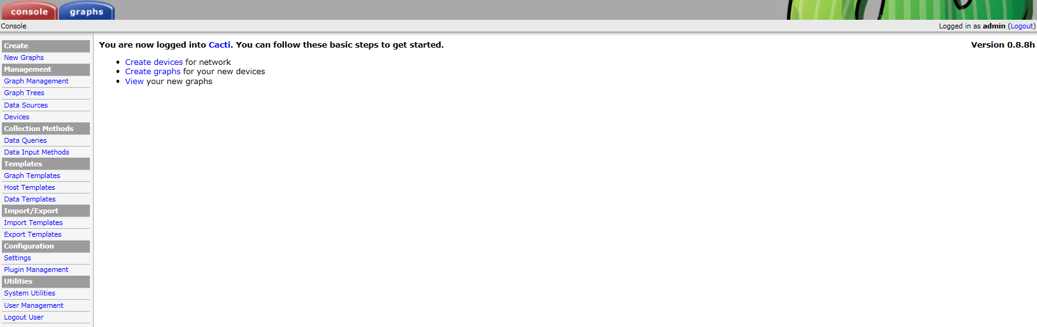

            - Install the Cacti plug-in.
- Choose Configuration > Plugin Management.
The Plugin Management page is displayed, as shown in Figure 1-1.
              - Plugin Management
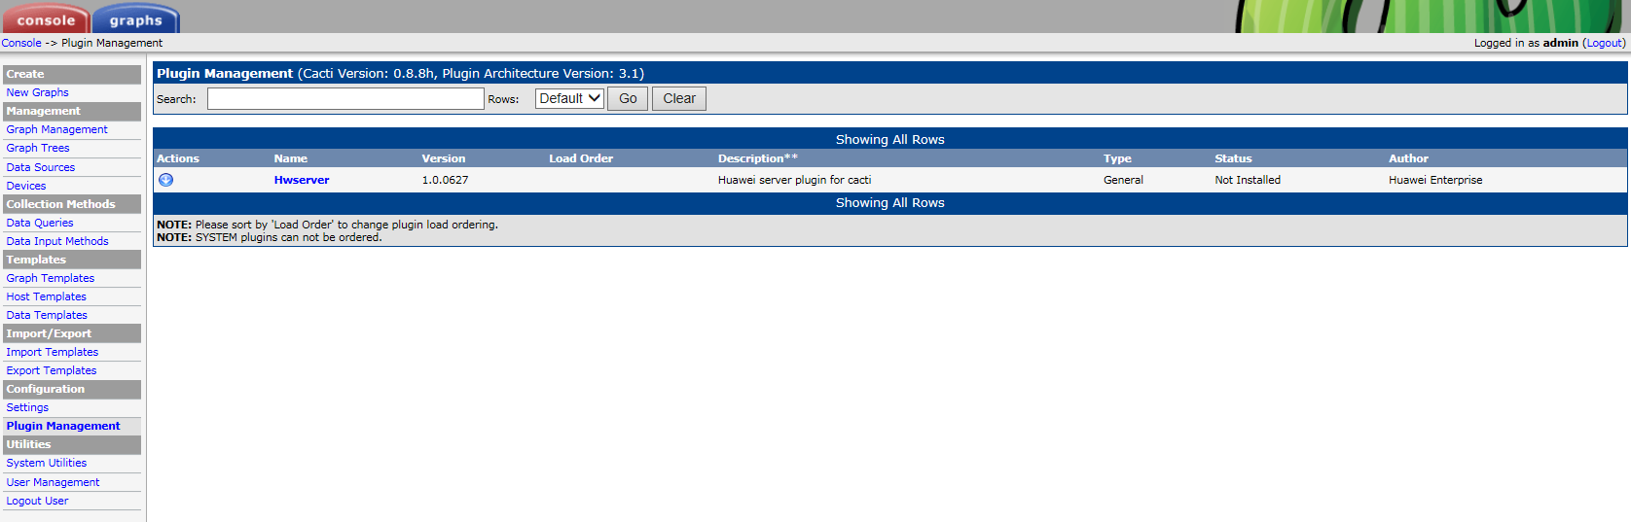

- Find the plug-in of which the name is Hwserver, and click in the row where the Hwserver plug-in is located.
The Cacti plug-in is installed, as shown in Figure 1-2.
              - Installation completed
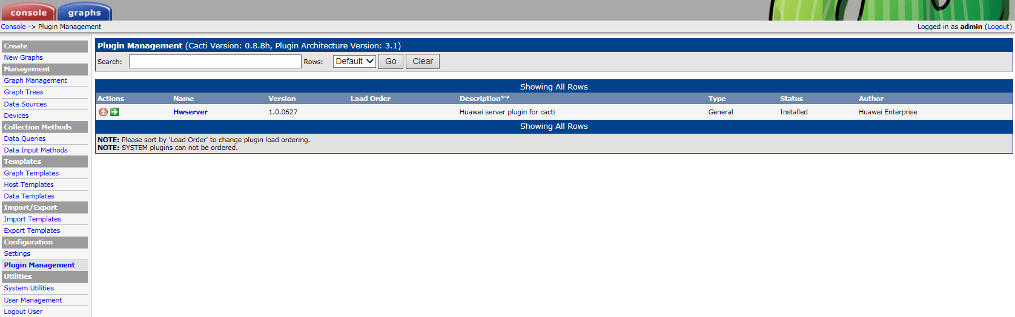

- Click to enable the Cacti plug-in.
The HUAWEI Server tab is displayed, as shown in Figure 1-3.
              - HUAWEI Server
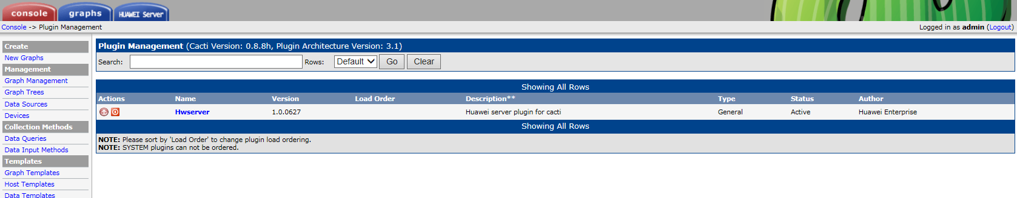

----End

Uninstalling the Cacti Plug-in
            - Log in to Cacti.
- Open the browser, enter http://Cacti IP address/cacti in the address box, and press Enter.
- Enter the user name and password, and click Login.
The Cacti main page is displayed, as shown in Figure 1-1.
              - Cacti main page
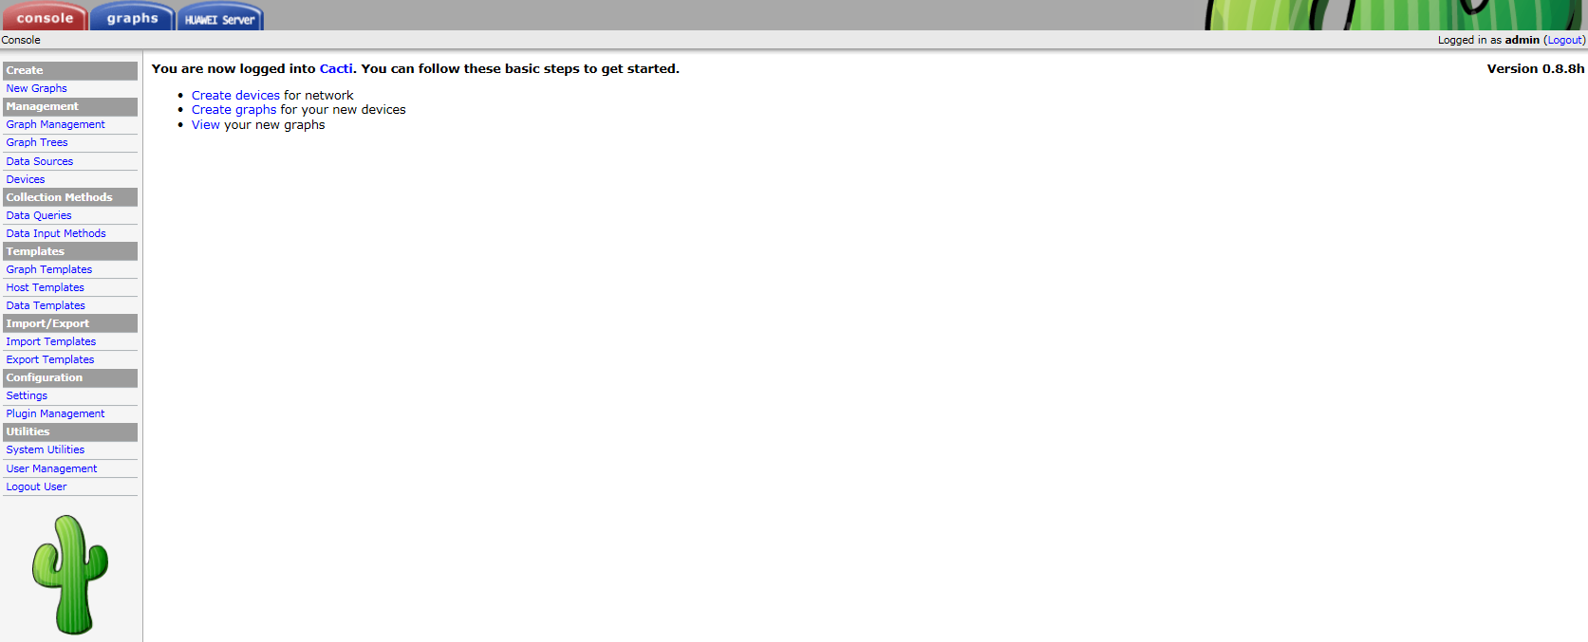

            - Uninstall the Cacti plug-in.
- Choose Configuration > Plugin Management.
The Plugin Management page is displayed, as shown in Figure 1-1.
              - Plugin Management
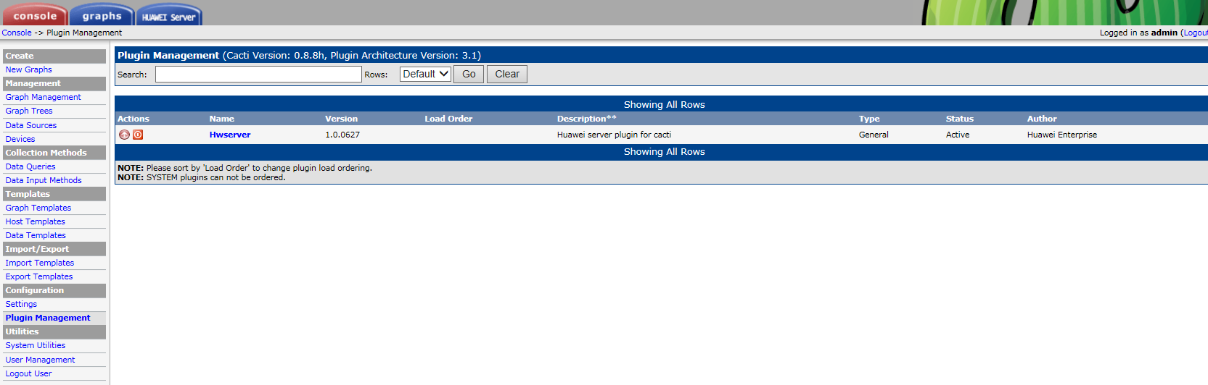

- Find the plug-in of which the name is Hwserver, and click in the row where the Hwserver plug-in is located.
The Cacti plug-in is uninstalled.
----End

Adding Servers

Manually Adding a Server
            - Log in to Cacti.
- Open the browser, enter http://Cacti IP address/cacti in the address box, and press Enter.
- Enter the user name and password, and click Login.
The Cacti main page is displayed, as shown in Figure 1-1.
              - Cacti main page

            - Choose Management > Devices.
The Devices page is displayed, as shown in Figure 1-1.
              - Devices
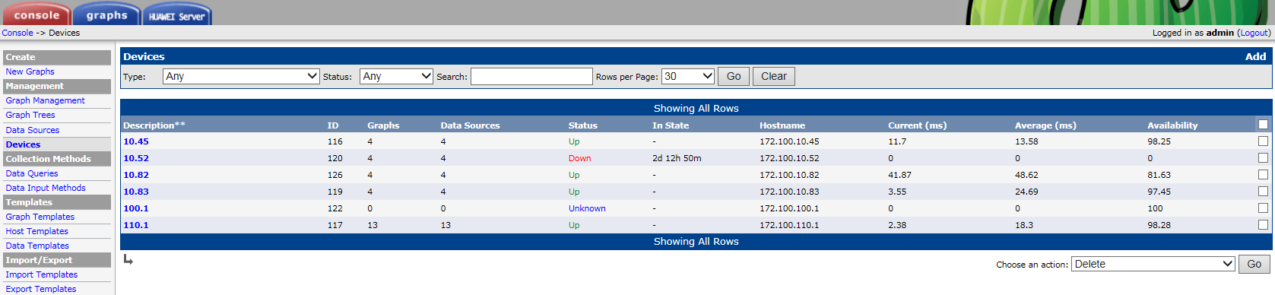

To delete servers that have been added, select the servers to be deleted, select Delete from the Choose an action drop-down list box, and click Go.
            - Click Add.
The page for adding a server is displayed, as shown in Figure 1-1.
              - Page for adding a server
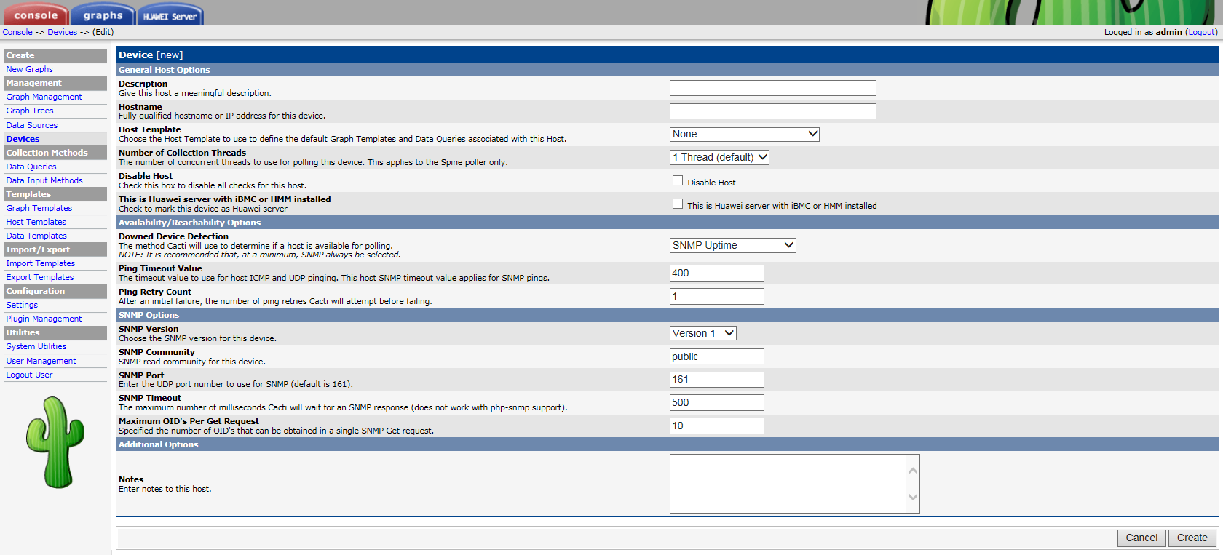

Table 1-1 describes the parameters to be set on this page. Retain default values for other parameters.
                - Parameter description
Module | Parameter | Description
General Host Options | Description | Set this parameter to a customized value.
General Host Options | Hostname | Enter the BMC IP address for a rack or high-density server, and enter the HMM IP address for an E9000 server. Table 1-1 lists the supported servers.
General Host Options | Host Template | Select Huawei Rack Server for a rack or high-density server, and select Huawei Blade Server for an E9000 server.
General Host Options | This is Huawei server with iBMC or HMM installed | Select This is Huawei server with iBMC or HMM installed.
SNMP Options (The parameter values of this module must be consistent with those on the server BMC WebUI or HMM WebUI.) | SNMP Version | Select Version 1, Version 2, or Version 3 according to the SNMP version enabled on the server.
 | SNMP Community | Specifies the SNMP community name (the default value is Huawei12#$). Set this parameter if the SNMP version is set to Version 1 or Version 2.
 | SNMP Username (v3) | Enter the server BMC or HMM user name (the default value is root).
 | SNMP Password (v3) | Enter the server BMC or HMM password (the default value is Huawei12#$).
 | SNMP Auth Protocol (v3) | Specifies the user authentication protocol. Select MD5 or SHA.
 | SNMP Privacy Passphrase (v3) | Enter the server BMC or HMM password (the default value is Huawei12#$).
 | SNMP Privacy protocol (v3) | Specifies the encryption protocol. Select AES or DES.

            - Enter server information according to Table 1-1, as shown in Figure 1-1.
              - Entering server information
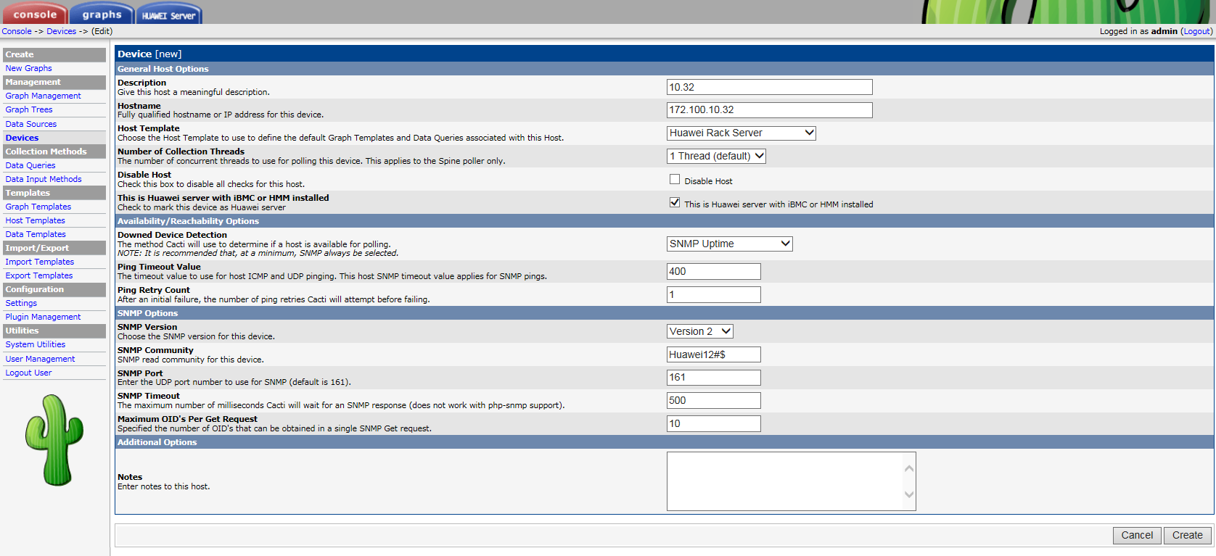

            - Click Create.
The server is added successfully.
----End

Importing Servers in Batches
            - Log in to Cacti.
- Open the browser, enter http://Cacti IP address/cacti in the address box, and press Enter.
- Enter the user name and password, and click Login.
The Cacti main page is displayed, as shown in Figure 1-1.
              - Cacti main page

            - Click HUAWEI Server.
The Huawei Server List page is displayed, as shown in Figure 1-1.
              - Huawei Server List
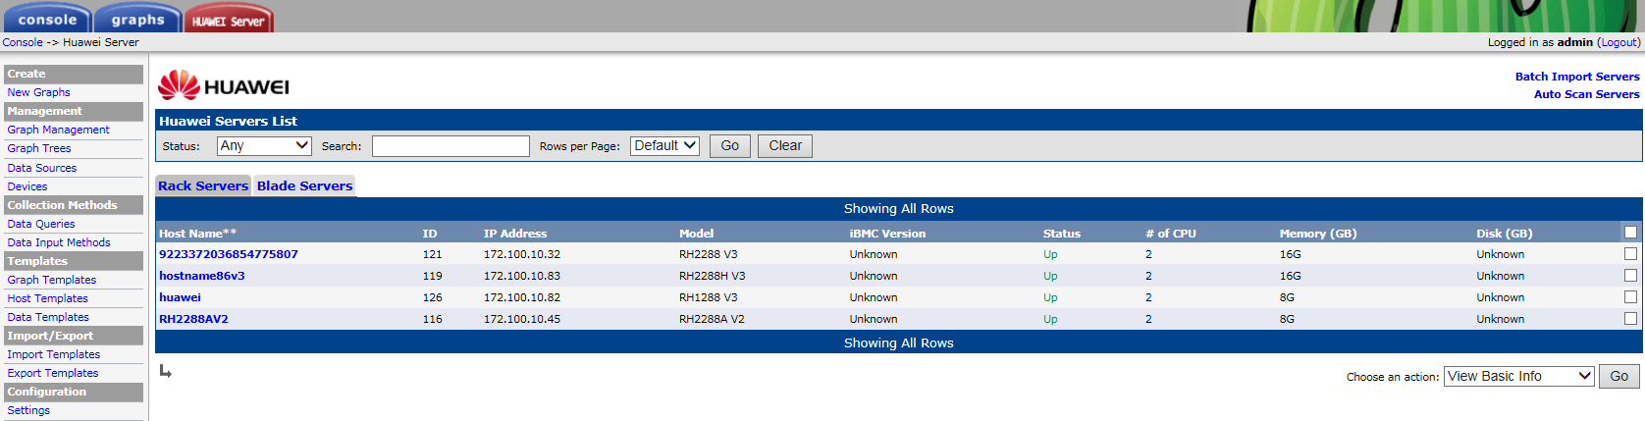

            - Click Batch Import Servers.
The Batch Import Servers page is displayed, as shown in Figure 1-1.
              - Batch Import Servers
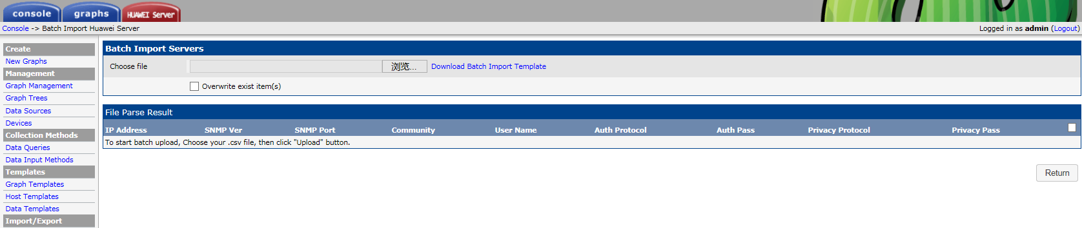

            - Click Download Batch Import Template.
The template file is downloaded successfully. Figure 1-1 shows the batch-import-template-v3.csv template file.
              - Template file

Table 1-1 describes the parameters.
                - Parameter description
Parameter | Description
ip | Enter the BMC IP address for a rack or high-density server, and enter the HMM IP address for an E9000 server. Table 1-1 lists the supported servers.
snmp_ver | Specifies the SNMP version. Enter 1, 2, or 3.
community | Specifies the SNMP community name (the default value is Huawei12#$). Set this parameter if the SNMP version is set to 1 or 2.
Set the following parameters only when the SNMP version is set to 3.
user_name | Enter the server BMC or HMM user name (the default value is root).
sec_level | Specifies the security level. Enter authNoPriv (authenticate without encryption) or authPriv (authenticate with encryption).
auth_protocol | Specifies the user authentication protocol. Enter MD5 or SHA.
auth_passphrase | Specifies the user authentication password. Enter the server BMC or HMM password (the default value is Huawei12#$).
priv_protocol | Specifies the encryption protocol. Enter AES or DES. You do not need to set this parameter if sec_level is set to authNoPriv.
priv_passphrase | Specifies the encryption password. Enter the server BMC or HMM password (the default value is Huawei12#$). You do not need to set this parameter if sec_level is set to authNoPriv.

            - Enter server information according to Table 1-1.
            - Click to import the template file.
The template file is imported successfully and server information is displayed on the page, as shown in Figure 1-1.
              - Template file imported successfully
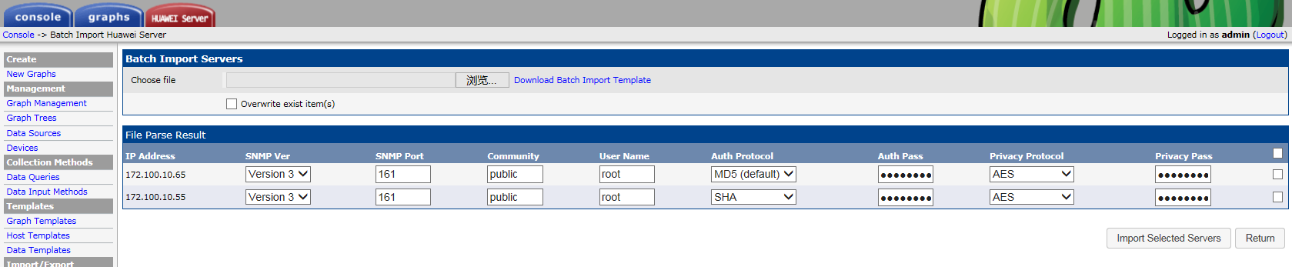

If information about servers that have been added is entered in the template file, select Overwrite exist item(s) and then import the template file. The servers will be added again.
            - Select the servers to be imported, and click Import Selected Servers.
The server import starts, as shown in Figure 1-1.
              - Server import progress
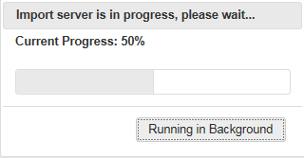

After the servers are imported, Import success is displayed on the page, as shown in Figure 1-2.
              - Servers imported successfully
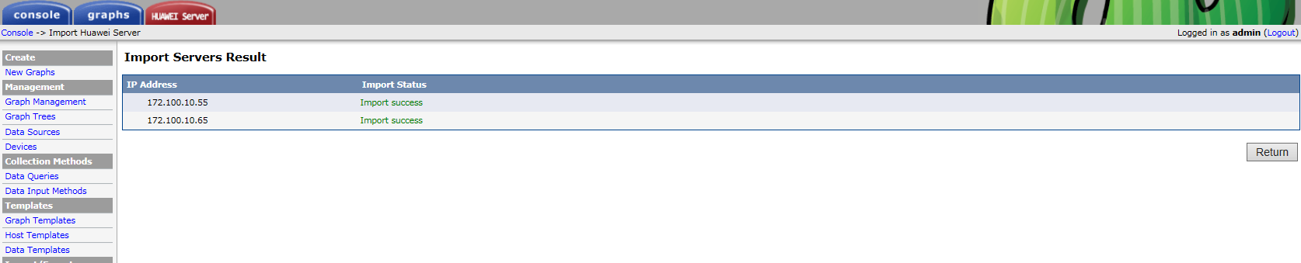

----End

Adding Servers by Automatic Scanning
            - Log in to Cacti.
- Open the browser, enter http://Cacti IP address/cacti in the address box, and press Enter.
- Enter the user name and password, and click Login.
The Cacti main page is displayed, as shown in Figure 1-1.
              - Cacti main page

            - Click HUAWEI Server.
The Huawei Server List page is displayed, as shown in Figure 1-1.
              - Huawei Server List

            - Click Auto Scan Servers.
The Auto Scan Huawei Server page is displayed, as shown in Figure 1-1.
              - Auto Scan Huawei Server
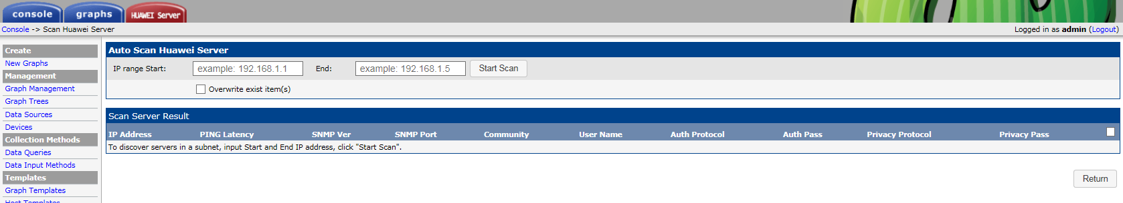

            - Enter the start IP address and end IP address of the search, and click Start Scan.
If servers that have been added are included in the IP address range, select Overwrite exist item(s) and then scan servers. The servers will be added again.
The automatic server scanning starts, as shown in Figure 1-1.
              - Automatic scanning
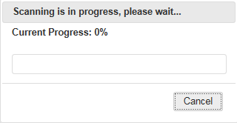

The scanning is successful, as shown in Figure 1-2.
              - Scanning succeeded
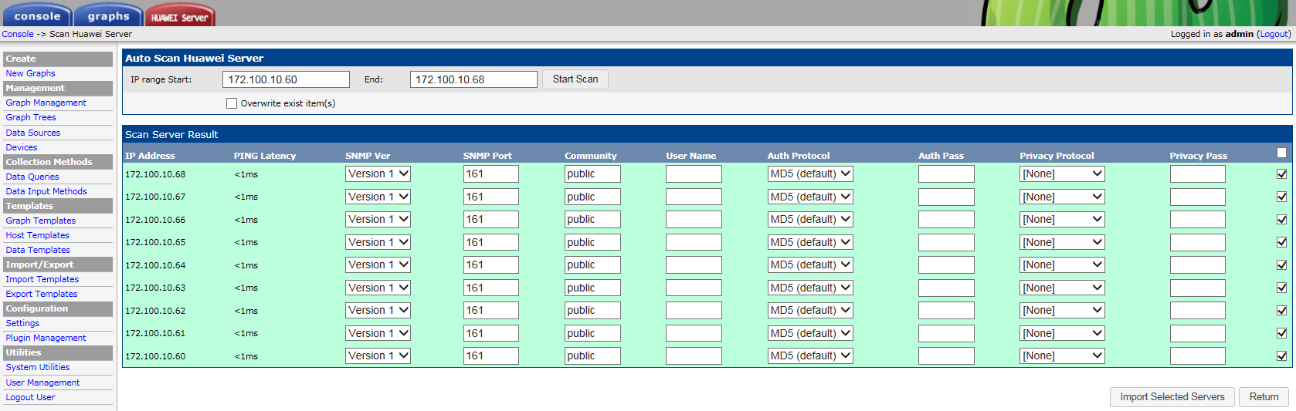

Table 1-1 describes the parameters.
                - Parameter description
Parameter | Description
SNMP Ver | Specifies the SNMP version. Select Version 1, Version 2, or Version 3.
SNMP Port | Retain the default value 161.
community | Specifies the SNMP community name (the default value is Huawei12#$). Set this parameter if the SNMP version is set to Version 1 or Version 2. Retain the default value public if the SNMP version is set to Version 3.
Set the following parameters only when the SNMP version is set to Version 3.
User Name | Enter the server BMC or HMM user name (the default value is root).
Auth Protocol | Specifies the user authentication protocol. Enter MD5 or SHA.
Auth Pass | Specifies the user authentication password. Enter the server BMC or HMM password (the default value is Huawei12#$).
Privacy Protocol | Specifies the encryption protocol. Enter AES or DES.
Privacy Pass | Specifies the encryption password. Enter the server BMC or HMM password (the default value is Huawei12#$).

            - Select the servers to be added, set the server SNMP service according to Table 1-1, and click Import Selected Servers.
The server adding starts, as shown in Figure 1-1.
              - Server adding progress

After the servers are added, Import success is displayed on the page, as shown in Figure 1-2.
              - Servers added successfully

----End

Querying Server Information

Viewing Basic Server Information
            - Log in to Cacti.
- Open the browser, enter http://Cacti IP address/cacti in the address box, and press Enter.
- Enter the user name and password, and click Login.
The Cacti main page is displayed, as shown in Figure 1-1.
              - Cacti main page

            - Click HUAWEI Server.
The Huawei Server List page is displayed, as shown in Figure 1-1.
              - Huawei Server List

            - View server information.
- To view rack or high-density server information, choose Rack Servers > Server host name.
Detailed server information is displayed, as shown in Figure 1-1.
              - Detailed server information
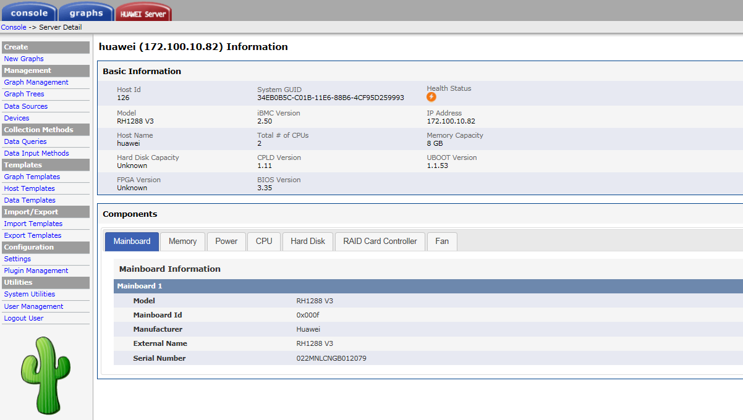

Table 1-2 provides the information that can be obtained about rack and high-density servers.
- To view blade server information, choose Blade Servers > Server host name.
Detailed server information is displayed, as shown in Figure 1-2.
              - Detailed server information
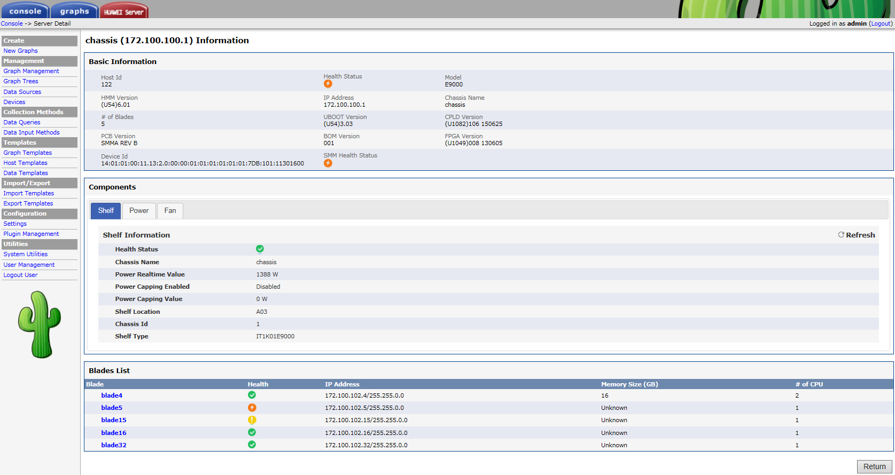

- Click a slot number (such as Blade4) in the Blades List area to view detailed information about the blade in this slot.
- Table 1-3 provides the information that can be obtained about blade servers.
----End

Viewing Server Performance Curves
            - Log in to Cacti.
- Open the browser, enter http://Cacti IP address/cacti in the address box, and press Enter.
- Enter the user name and password, and click Login.
The Cacti main page is displayed, as shown in Figure 1-1.
              - Cacti main page

            - Create performance graphs.
Newly added servers do not have performance graphs by default. You need to create performance graphs manually.
- Choose Management > Devices.
The Devices page is displayed, as shown in Figure 1-1.
              - Devices
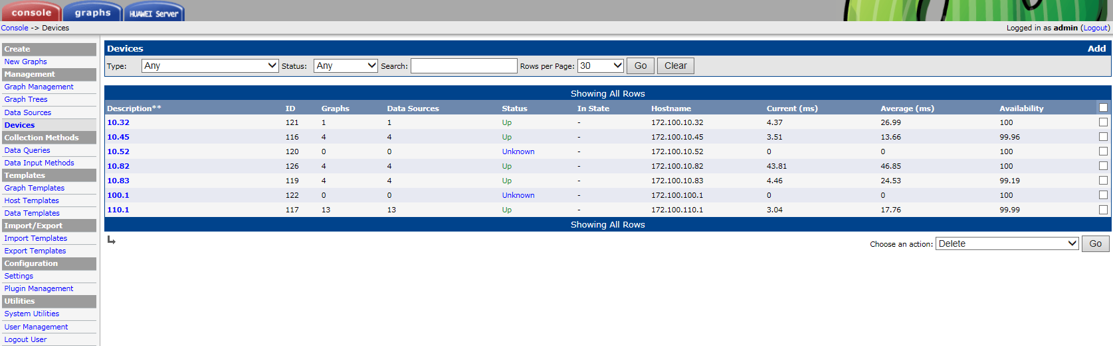

- Create the value (such as 10.52) of Description of a server.
The SNMP Information page is displayed, as shown in Figure 1-2.
              - SNMP Information
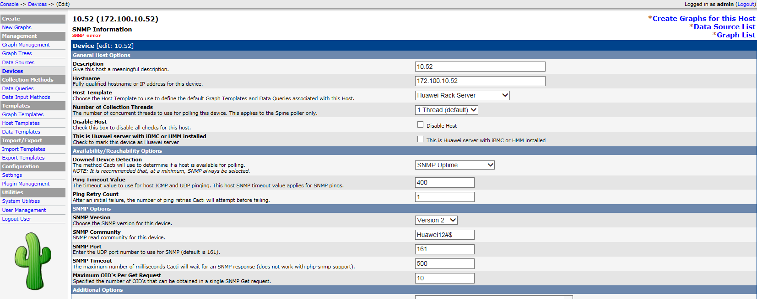

- Click Create Graphs for this Host in the upper right corner.
The Create New Graphs page is displayed, as shown in Figure 1-3.
              - Create New Graphs
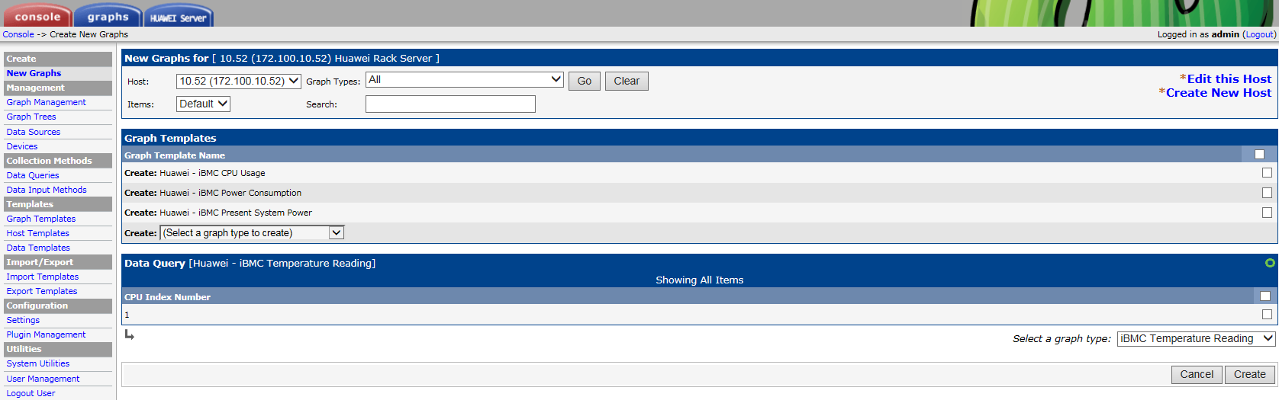

- Select the types of the performance graphs to be created (Performance graph creation in Table 1-2 and Table 1-3 describes the supported performance graph types), as shown in Figure 1-4.
              - Selecting performance graph types
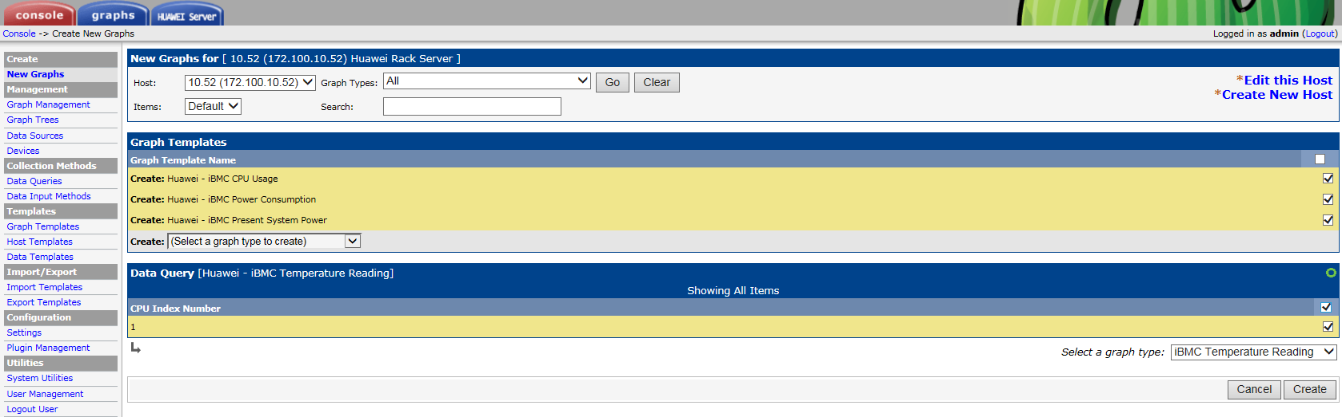

- Click Create.
The performance graph creation starts. You can view the performance graphs about 10 minutes later after the creation is successful.
            - View performance graphs.
- Click Graphs.
The Tree Mode page is displayed, as shown in Figure 1-1.
              - Tree Mode
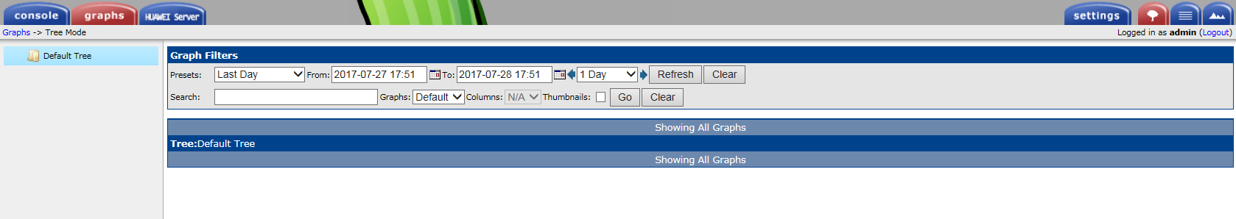

- Click  in the upper right corner.
The List Mode page is displayed, as shown in Figure 1-2.
              - List Mode
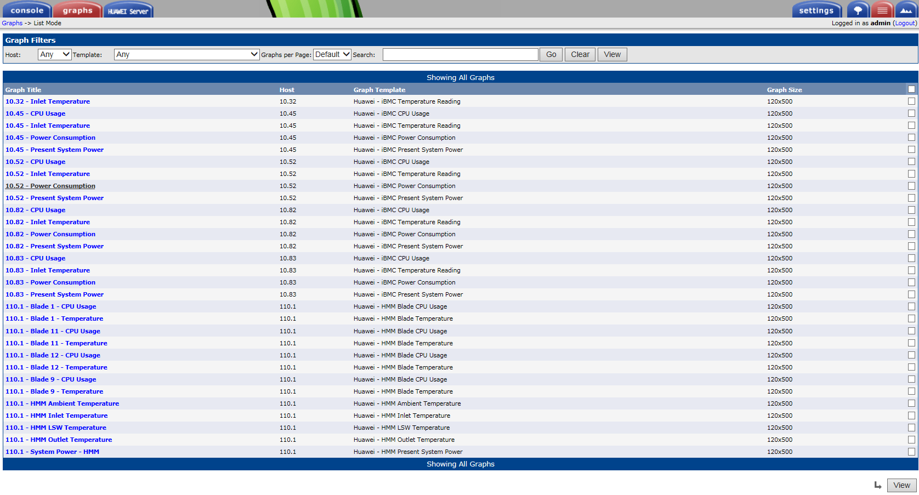

- Click a performance graph title.
The performance graphs are displayed, as shown in Figure 1-3.
              - Performance graphs
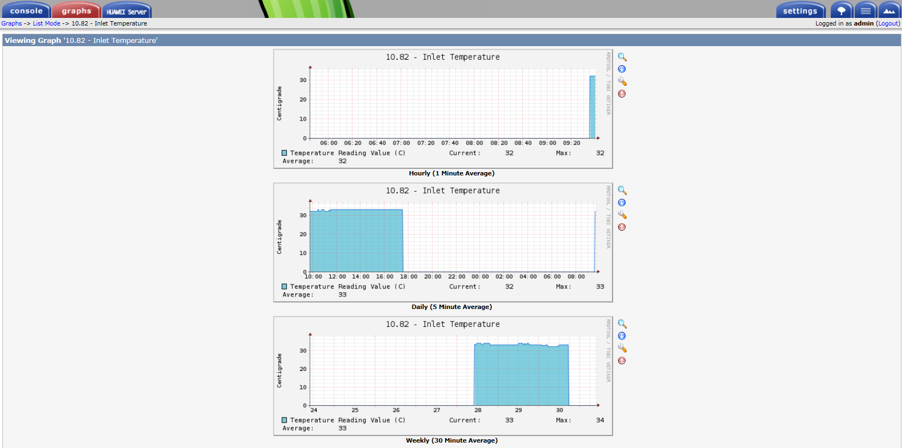

You can select multiple performance graph titles and click View to view performance graphs in batches.
----End

